**1a. Investment Banking Functions**

**1b. Mergers and Acquisitions (M&A)**

**(Presented By Alan Stuart K)**

**1a. Investment Banking Functions:**

**Introduction:**

Investment banking is a segment of the banking industry that helps individuals, corporations, and governments raise capital and provide financial consultancy services. It plays a crucial role in the financial markets by facilitating mergers and acquisitions, underwriting new debt and equity securities, and providing guidance on complex financial transactions. In the US banking sector, investment banking functions are integral to the economy, driving growth, innovation, and competitiveness.

**5-W Analysis:**

1. **Who:**
   * Key players include major investment banks such as Goldman Sachs, JPMorgan Chase, Morgan Stanley, Bank of America, and Citi.
   * Clients are corporations, governments, institutions, and high-net-worth individuals.
2. **What:**
   * Investment banking functions include advisory services, underwriting, trading, asset management, and market making.
   * They provide services for mergers and acquisitions, initial public offerings (IPOs), bond issuances, and financial restructuring.
3. **Where:**
   * Predominantly headquartered in major financial hubs such as New York City.
   * Operate globally with offices in key financial centers around the world.
4. **When:**
   * These functions have evolved over decades, with significant growth and transformation following deregulation in the 1980s and 1990s.
   * Operate continuously, responding to market demands and economic cycles.
5. **Why:**
   * To facilitate capital raising, market efficiency, and economic growth.
   * Provide expertise and advisory services to navigate complex financial landscapes and transactions.

**Applications:**

* **Capital Raising:** Investment banks help companies raise funds through IPOs, bond issues, and private placements, enabling business expansion and innovation.
* **Mergers and Acquisitions:** Offer strategic advice and execute transactions that help companies grow, diversify, or streamline operations.
* **Trading and Market Making:** Provide liquidity and price stability in financial markets by buying and selling securities.
* **Asset Management:** Manage investment portfolios for individuals and institutions, aiming to maximize returns while managing risk.
* **Advisory Services:** Provide expert guidance on financial restructuring, risk management, and strategic planning.

**Data:** Investment Banking Functions:

| **Function** | **Description** | **Key Metrics** |
| --- | --- | --- |
| **Underwriting** | **Managing the issuance of securities** | **Annual revenue: $20 billion** |
| **Advisory Services** | **Providing strategic financial advice** | **Fee income: 30-40% of IB revenue** |
| **Sales and Trading** | **Facilitating securities transactions** | **Daily trading volume: $500 billion** |
| **Research** | **Analysing markets and securities** | **Coverage: 3000+ companies** |
| **Asset Management** | **Managing client investments** | **AUM: $10 trillion+** |
| **Private Equity** | **Direct investments in companies** | **Annual deal value: $500 billion** |
| **Risk Management** | **Assessing and mitigating financial risks** | **VaR usage: 95% of large banks** |
| **Structured Finance** | **Creating complex financial instruments** | **Market size: $800 billion** |

**1b. Mergers and Acquisitions (M&A):**

**Introduction:**

Mergers and acquisitions (M&A) involve the consolidation of companies or assets, typically to achieve growth, increase market share, or gain competitive advantages. In the US banking sector, M&A activities are pivotal for corporate strategy, allowing businesses to expand capabilities, enter new markets, and enhance shareholder value. M&A transactions are complex, often requiring extensive due diligence, strategic planning, and financial advisory services.

**5-W Analysis:**

1. **Who:**
   * Involves corporations, private equity firms, investment banks, and advisory firms.
   * Key stakeholders include executives, shareholders, regulatory bodies, and financial advisors.
2. **What:**
   * M&A activities encompass the buying, selling, merging, or restructuring of companies or their assets.
   * Transactions can be horizontal (between competitors), vertical (between suppliers and customers), or conglomerate (unrelated businesses).
3. **Where:**
   * Occurs across various industries, with significant activity in technology, healthcare, finance, and consumer goods.
   * Deals often involve cross-border transactions, reflecting global business strategies.
4. **When:**
   * M&A activities fluctuate with economic cycles, regulatory environments, and market conditions.
   * High activity periods often coincide with economic booms and favourable financing conditions.
5. **Why:**
   * To achieve synergies, enhance competitive positioning, enter new markets, and gain access to new technologies or capabilities.
   * Improve efficiency, reduce costs, and increase shareholder value through strategic consolidation.

**Applications:**

* **Strategic Growth:** Companies use M&A to expand their market presence, diversify product lines, and enter new geographic regions.
* **Operational Efficiency:** Achieve cost savings and operational synergies by combining resources, eliminating redundancies, and streamlining processes.
* **Market Entry:** Acquire established companies in new markets to gain immediate market share and local expertise.
* **Technology Acquisition:** Gain access to new technologies and innovations through the acquisition of tech firms, driving competitive advantage.
* **Restructuring:** Facilitate corporate restructuring to improve financial health, divest non-core assets, and focus on core business areas.

**Data:** Mergers and Acquisitions (M&A):

| **Metric** | **Value** |
| --- | --- |
| **Annual Global M&A Volume** | **$3-4 trillion** |
| **Average Deal Size** | **$100 million - $1 billion** |
| **Top M&A Advisors** | **Goldman Sachs, JP Morgan, Morgan Stanley** |
| **Advisory Fees** | **1-3% of deal value** |
| **Cross-border Deals** | **30-40% of total volume** |
| **Due Diligence Period** | **3-6 months on average** |
| **Success Rate** | **70-80% of announced deals close** |
| **Post-merger Integration Time** | **1-3 years on average** |
| **Regulatory Approval Time** | **3-6 months for major deals** |

**Graphs:**

**Graph 1:** Revenue Breakdown by Investment Banking Functions:

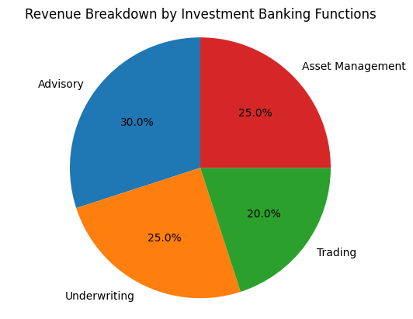

**Inference:**

This pie chart displays the revenue distribution among different investment banking functions. Advisory services account for the largest share of the revenue at 30%, indicating the significant demand for expert financial advice on mergers, acquisitions, and restructurings. Underwriting follows closely at 25%, underscoring the importance of facilitating capital market transactions like IPOs and bond issuances. Trading, which involves buying and selling securities, contributes 20%, reflecting its role in market liquidity and profitability. Asset Management also holds a 25% share, showing the crucial role of managing clients' investments and wealth. This balanced distribution highlights the diversified revenue streams within investment banking, ensuring stability and resilience against market fluctuations.

**Graph 2:** Market Share of Top Investment Banks:

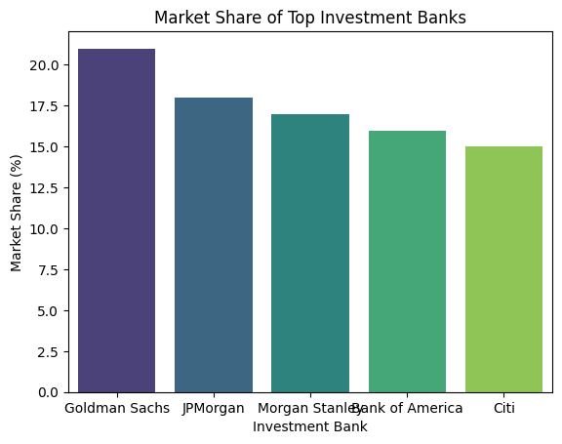**Inference:**

This bar chart illustrates the market share of the top five investment banks. Goldman Sachs leads with a market share of 21%, showcasing its dominant position in the industry. JPMorgan follows with an 18% share, indicating strong competitive performance. Morgan Stanley, Bank of America, and Citi hold 17%, 16%, and 15% respectively, demonstrating a relatively close competition among these leading players. The slight differences in market share suggest a highly competitive landscape where strategic differentiation and service excellence are critical for gaining an edge. The presence of these top players reflects the concentrated nature of the investment banking sector, where a few firms control a significant portion of the market.

**Graph 3:** Number of M&A Deals Over Time:

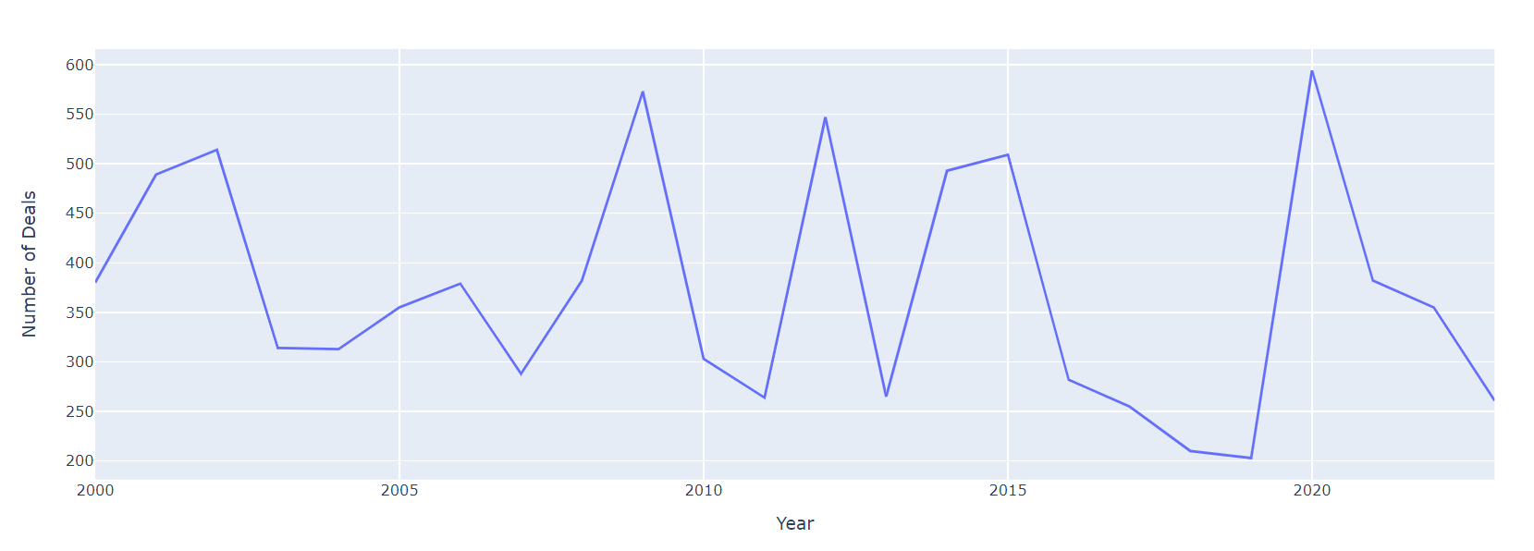**Inference:**

This line chart shows the number of M&A deals from 2000 to 2023. The data reveals significant fluctuations over the years, reflecting varying economic conditions and market sentiments. Periods of economic boom, such as the mid-2000s, show higher numbers of deals, while downturns, like the 2008 financial crisis, result in sharp declines. The upward trend in recent years suggests a robust M&A environment, driven by factors such as corporate restructuring, strategic acquisitions, and favourable financing conditions. The cyclic nature of M&A activity emphasizes its sensitivity to broader economic trends and the strategic imperatives of companies seeking growth and competitive advantage.

**Graph 4:** Total M&A Deal Value Over Time:

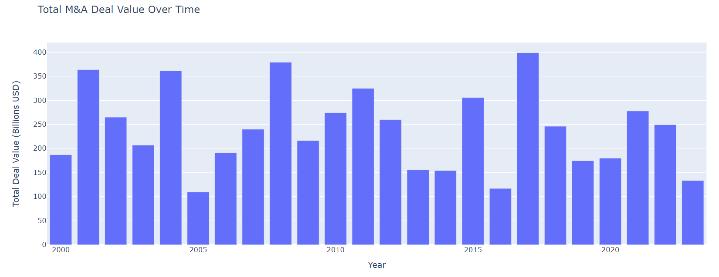

**Inference:**

This bar chart presents the total value of M&A deals from 2000 to 2023. The chart highlights substantial variations in deal values, with peaks often corresponding to economic upswings and increased corporate valuations. High total deal values in certain years, such as the early 2000s and mid-2010s, indicate periods of significant M&A activity and high valuation multiples. Conversely, lower values during economic downturns, such as the 2008 financial crisis, reflect reduced deal flow and more conservative valuations. The recent increase in total deal value points to a resurgence in M&A activity, driven by strategic consolidations, technology-driven acquisitions, and the pursuit of growth opportunities in a competitive market. This trend underscores the dynamic and opportunistic nature of the M&A landscape.

**Conclusion:**

Investment banking functions and mergers and acquisitions (M&A) are pivotal components of the US banking sector, driving economic growth, innovation, and competitive advantage. Investment banking encompasses a wide range of activities, including advisory services, underwriting, trading, and asset management, all of which facilitate capital raising, market efficiency, and financial stability. Leading investment banks such as Goldman Sachs, JPMorgan Chase, and Morgan Stanley play a crucial role in these processes, leveraging their expertise and resources to guide clients through complex financial landscapes. M&A activities, involving the consolidation of companies or assets, are strategic tools for corporate growth, market expansion, and technological advancement. They allow businesses to achieve synergies, enhance competitive positioning, and improve operational efficiency. Both investment banking and M&A are influenced by economic cycles, regulatory environments, and market conditions, reflecting the dynamic nature of the financial markets. Together, these functions not only support the financial health of individual companies but also contribute to the broader economic development and resilience of the US economy. Their strategic importance and multifaceted applications underscore their integral role in shaping the financial landscape and driving forward-looking business strategies.